QUEST

The Journal of the Emmet County Genealogical Society
Volume 25, No. 3 August 2025

The Emmet County Genealogical Society meets at 6:30 p.m. on the first Tuesday of every month at the American Legion Hall, Weaver Lindemuth Post 194, 455 Bay Street, Petoskey, MI. (1/2 block up from Stafford’s Perry Hotel) Please use side door entrance.

Our meetings are always open to the public.
Upcoming meetings:
September 2, 2025
October 7, 2025
November 4, 2025

Hello!

Hello there! My name is Keith Greenwald and I am the new editor of the Quest. I have been a club member for five years and I honestly say it has been well worth the $15.00 annual dues. I have learned many research tips from other members and have enjoyed some interesting guest speakers. At our monthly meetings, after we finish the business items, we have sharing time. Members are welcome to present old photos, clippings or share research findings that are of interest to the group. I have learned a lot about the history of the area and what life was like when my ancestors were living here.

Where did our summer go? For Jan and me, it seemed to fly by so fast. It was a warm one with sufficient rainfall that made our lawn and garden really thrive. I thought it was unusual that we had adequate moisture to keep our lawn from turning brown like it does most years. But I love fall! The cooler temperatures, harvest, the beautiful colors, hunting and of course football! We like to travel in the fall and are planning a trip to Missouri in September or October.

Wanted: Your photos, stories, and articles!

This is our society’s newsletter so you are welcome to contribute articles or photos I could use. You can bring them to one of our meetings, email them to me or send them regular mail. emmetcogensociety@gmail.com or Keith Greenwald, 415 Meadow Lane, Petoskey, MI 49770.

Website News

Have you visited our website recently? Did you know that it contains 20 links to other free websites to help you in your family history research? It has been interesting to see who has been using our website. Each month, as website manager, I receive a report from our host company showing how many people have visited our site and where they are from. During the past 90 days, we had sixty-seven visitors of which fifty were first-timers. Of the sixty-seven, fifty-eight were from the U.S., three were from China, three were from Bangladesh and one was from the Philippines.

Oktoberfest Trivia
Prince Regent Ludwig of Bavaria (who became King Ludwig I) and Princess Therese of Saxony-Hildburghausen were married on 12 October 1810. The wedding celebration took place in a meadow which was later named Theresienwiese (Therese’s meadow) in honor of the bride. It featured a horse race though no beer tents or fairground rides. But a good time was had by all and so Oktoberfest was born. Today it is a two-week long festival, beginning in September (September 18 this year) and ending on the first Sunday in October. The September opening means warmer weather and longer days which contribute to the comfort and pleasure of visitors. But the Münchners don’t call it Oktoberfest, but Wiesn or Oide Wiesn. Wiese being the word for meadow, and Oide indicating old. Today the Oide Wiesn is a separate festival that emphasizes the traditional character of the Oktoberfest with brass music and historical attractions. Though Munich is the traditional center of Oktoberfest, you can often find local celebrations, especially as sponsored by Germanic groups or restaurants. And in any event, you can enjoy a Wiesnherz or meadow-heart, an often elaborately decorated Lebkuchen (gingerbread cookie) with its traditional heart shape and sweet sayings.
The Sacramento German Genealogy Society
Der Bote, The Messenger September 2023, https://sggs.us

Widen the Search Area
It is important not to limit the geographical extent of our search for records. It may seem unlikely for our horse and buggy, shanks, mare ancestors to have attended a church twenty miles away from their home, or meet a spouse two counties apart, but such things did happen more often than you think. Also keep in mind that in the early years of settlement in a new area, the population might be so thin that a single minister served several congregations in a large circuit, so the records for a wide region might be found together.

The Rosco Flatfoot, August 2025

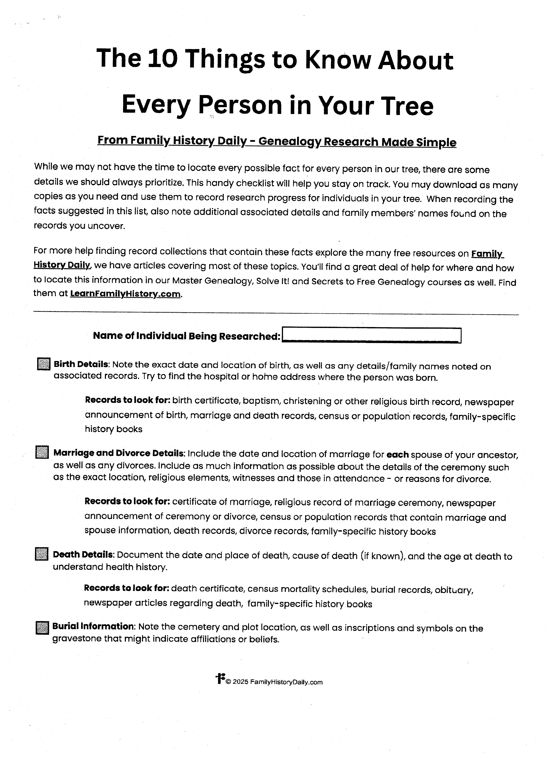
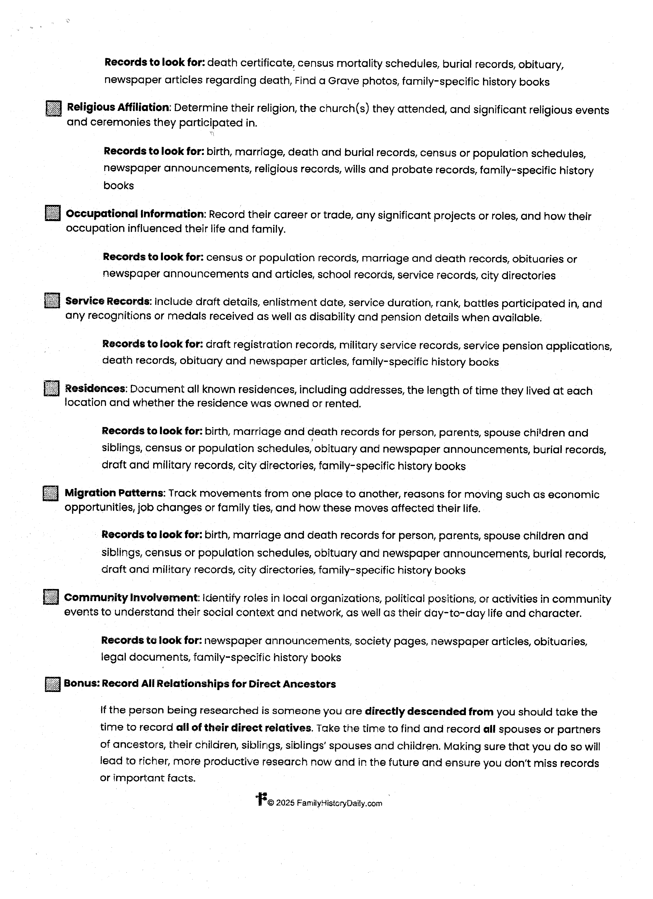

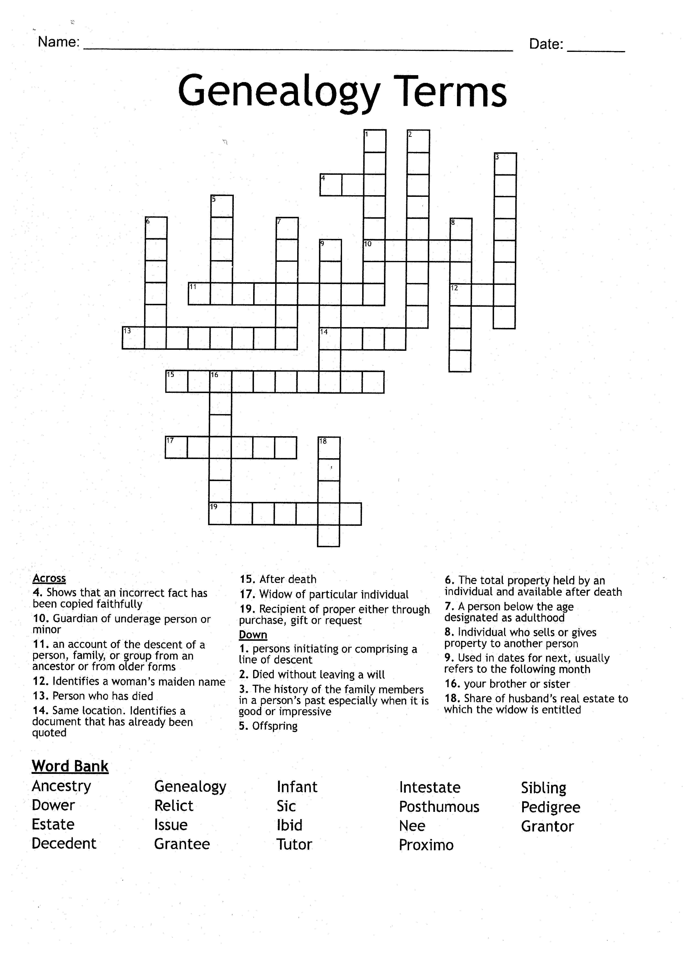

Remembering Kim
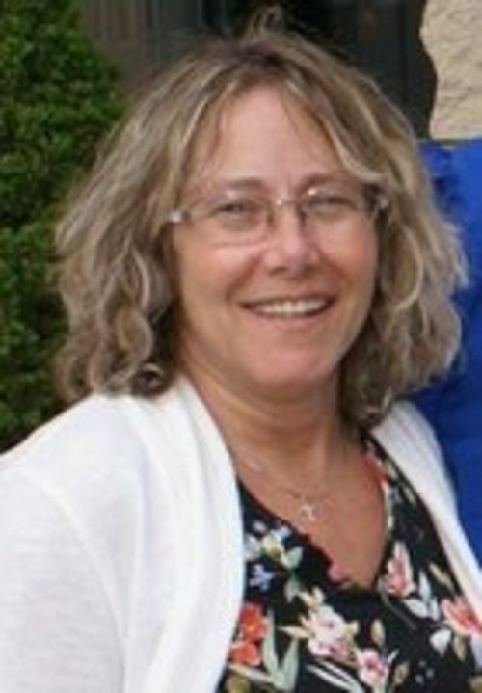

Kim Morgan passed away on February 20, 2025.
Kim was active in our society for over eighteen years.
She served as an officer, managed the website and newsletter,
and oversaw our cookbook sales. She will be missed dearly.
Funds we received as memorials for her
were given to the Alanson Beautification Center (Hillside Gardens).

